SQL Server Integration Services

# Module 03 – Lab 07: Data Flow

1. Launch Visual Studio 2019.
2. Create new integration services project.
3. Set up a connection manager for the database. In the bottom center pain under Connection Manger, right-click select New Ole-DB Connection.  
   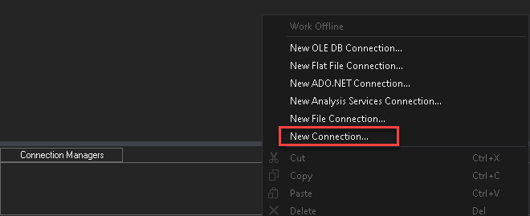
4. In Configure OLE DB Connect Manager, click New.  
   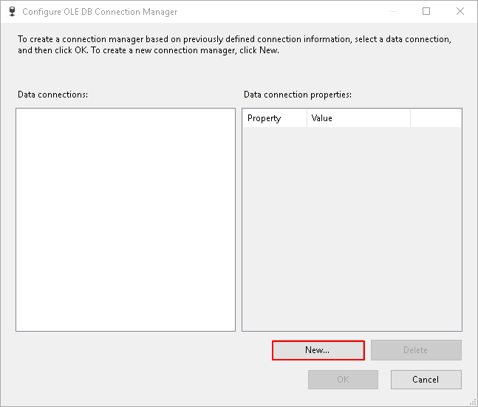
5. In connection manager, type the server’s name, select the database “AdventureWorks” and click OK.  
   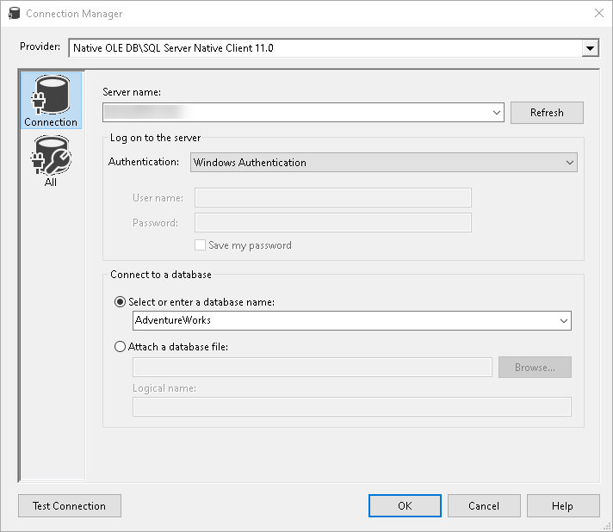
6. Click OK in Configure OLE DB Connection Manager. A single connection under Connection Manager should be visible.  
     
   *Hint: Rename the connection manager to OLEDB.ServerName.DatabaseName. This will make it easier to identify which driver is being used for the driver.*
7. Create an Execute T-SQL Task. Rename it to “Setup Staging Tables”.  
   
8. Copy the T-SQL Code in CreateTablesForLab.sql and paste it in the SQLStatement.  
   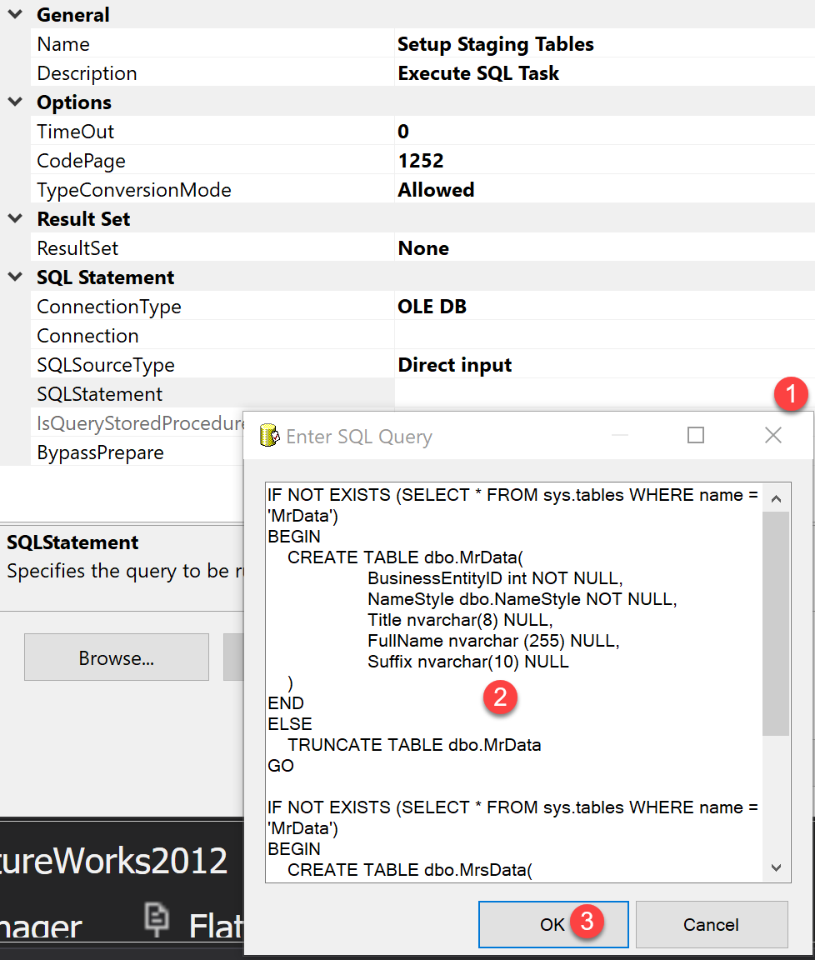
9. Update the Connection to point to connection created in step #6. Right click on the “Setup Staging Tables” Task and select execute, as these tables will be required at a later step.
10. Create a Data Flow task and rename it to “Load His and Her Customer Data”. Link the “Setup Staging Tables” to data flow task.  
    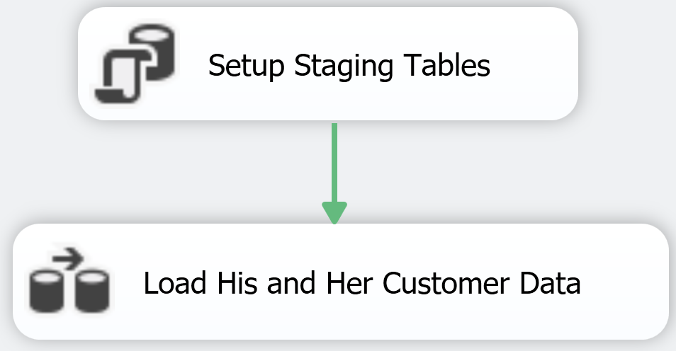
11. Double-click on the data flow task, to start building the data flow for loading CSV data, removing the duplicates, distributing the data into multiple streams, splitting the data by His and Her dataset, combing the respective data from His and Her streams, build a new derived column for each set, sort each set, and save it in their respective tables.
12. So, to start, create a Flat File Source task. Rename it to “Load Customer CSV Data”. Double-click it to configure the task and click “New” to build a new connection manager object.
13. Rename the object to CSVFile.CustomerData. Point the file to CustomerData.csv.

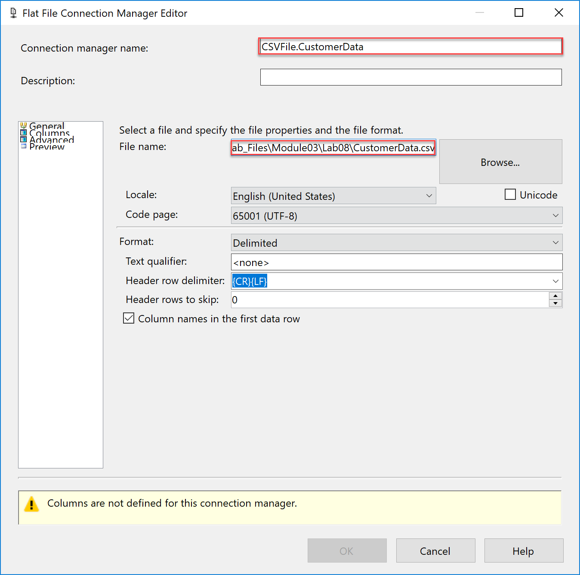

1. Next click on Advanced on the left side, to configure the columns.
2. Update each column to make sure the Type and Width information matches the table below.  
   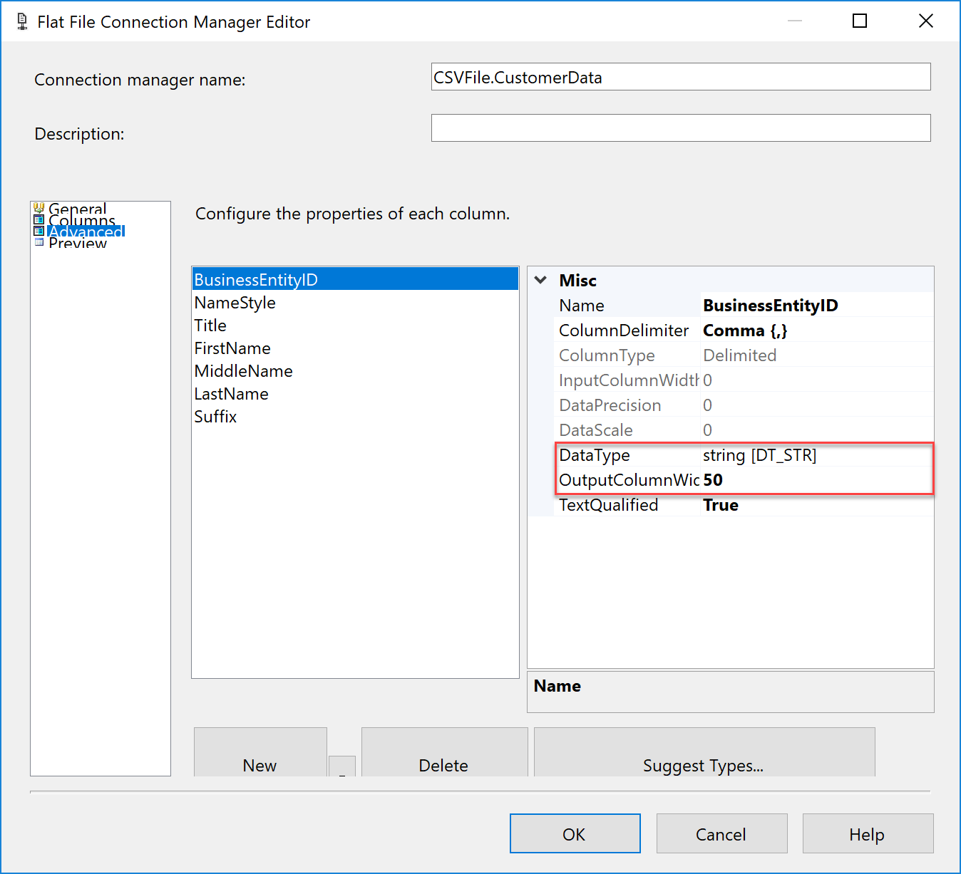

|  |  |  |
| --- | --- | --- |
| Column Name | Data Type | Output Column Width |
| BusinessEntityID | four-byte signed integer [DT_I4] | 0 |
| NameStyle | single-byte signed integer [DT_I1] | 0 |
| Title | Unicode string [DT_WSTR] | 8 |
| FirstName | Unicode string [DT_WSTR] | 50 |
| MiddleName | Unicode string [DT_WSTR] | 50 |
| LastName | Unicode string [DT_WSTR] | 50 |
| Suffix | Unicode string [DT_WSTR] | 10 |

1. After updating click OK to save the connection manager. In the Flat File Source Editor, click on the Columns to update the column mapping and click OK.
2. Add a new task Aggregate and rename it to “Remove Duplicate Rows” and link it to “Load Customer CSV Data”.  
   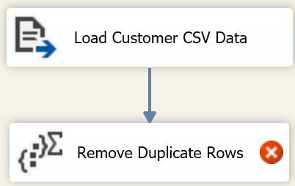
3. Double-click on Remove Duplicate Rows to configure. Select all the rows make sure option is set to group-by.  
   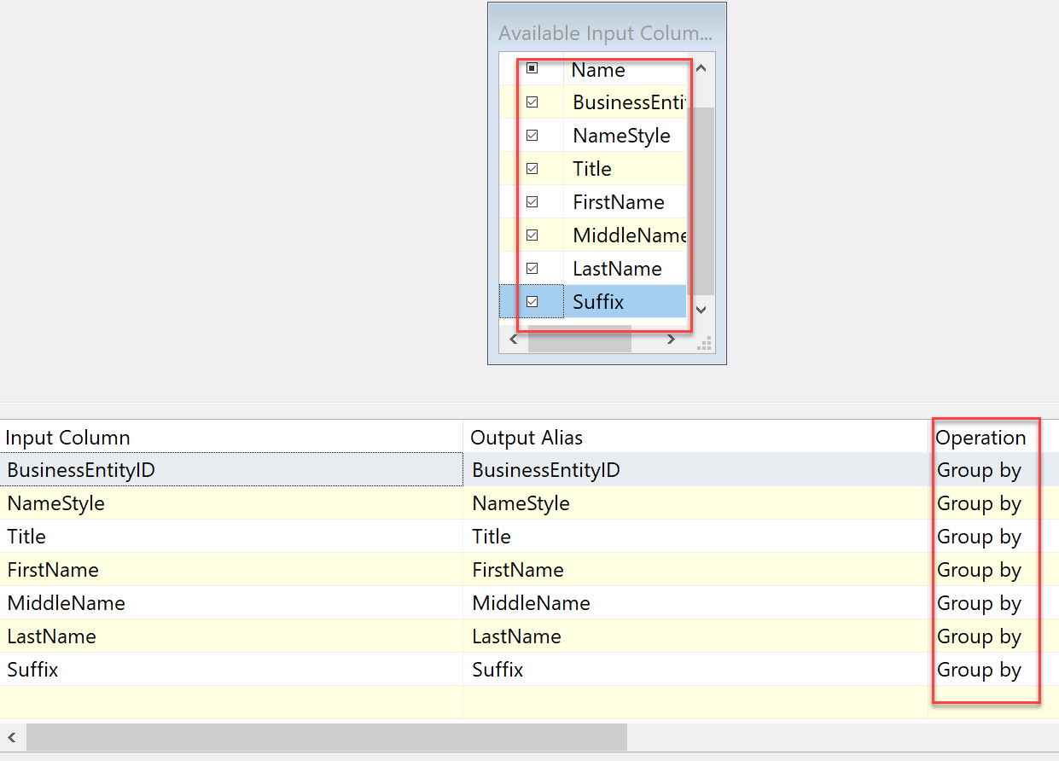
4. Next add Balance Data Distributor. Link it to “Remove Duplicate Rows”. This allows us to use multiple threads to process larger datasets.  
   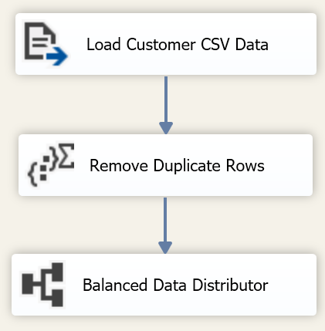
5. Next add two Conditional Split tasks, rename the first one to “Data Split #1” and second one to “Data Split #2”. For each task link it back to Balanced Data Distributor.  
   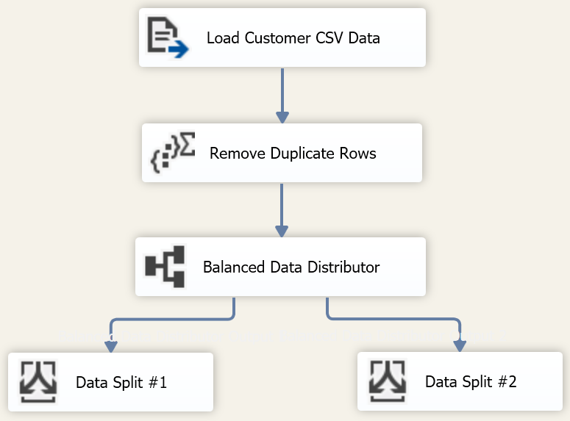
6. Next configure EACH Data Split task, with following expressions and rules. Must be completed for BOTH Data Split #1 and Data Split #2.  
   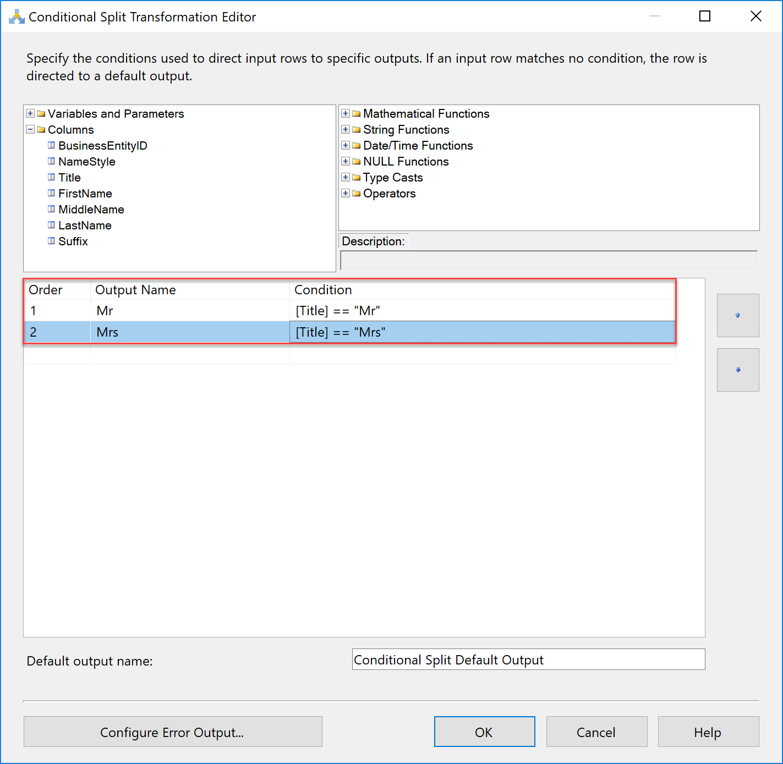
7. Create two new tasks for “Union All”. Rename one to “Combine His Data” and other to “Combine Her Data”.   
   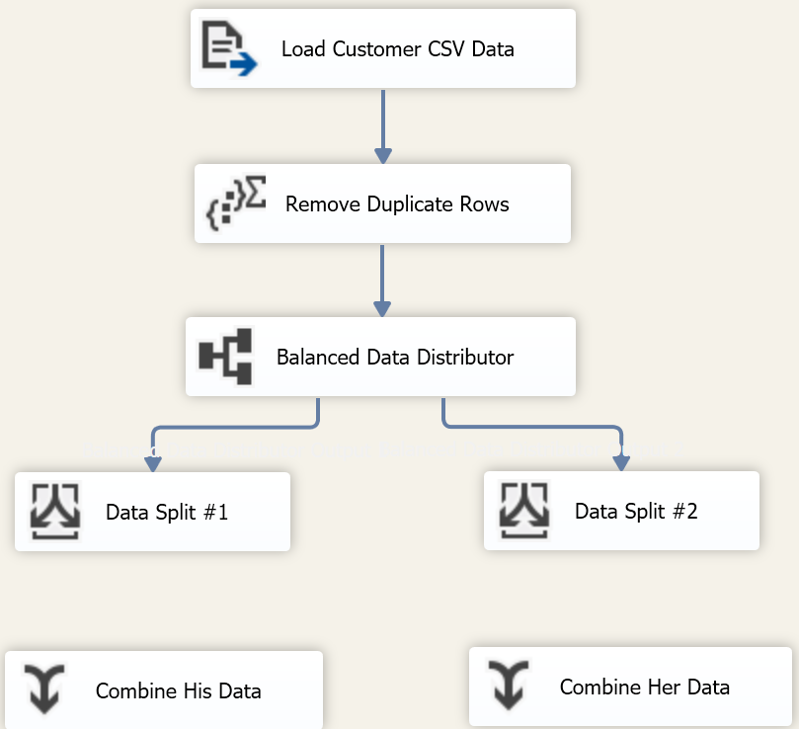
8. Drag an arrow from Data Split #1 to Combine His Data, when you do you’ll get a below dialog box. Select “Mr” stream in the Output and click OK.  
   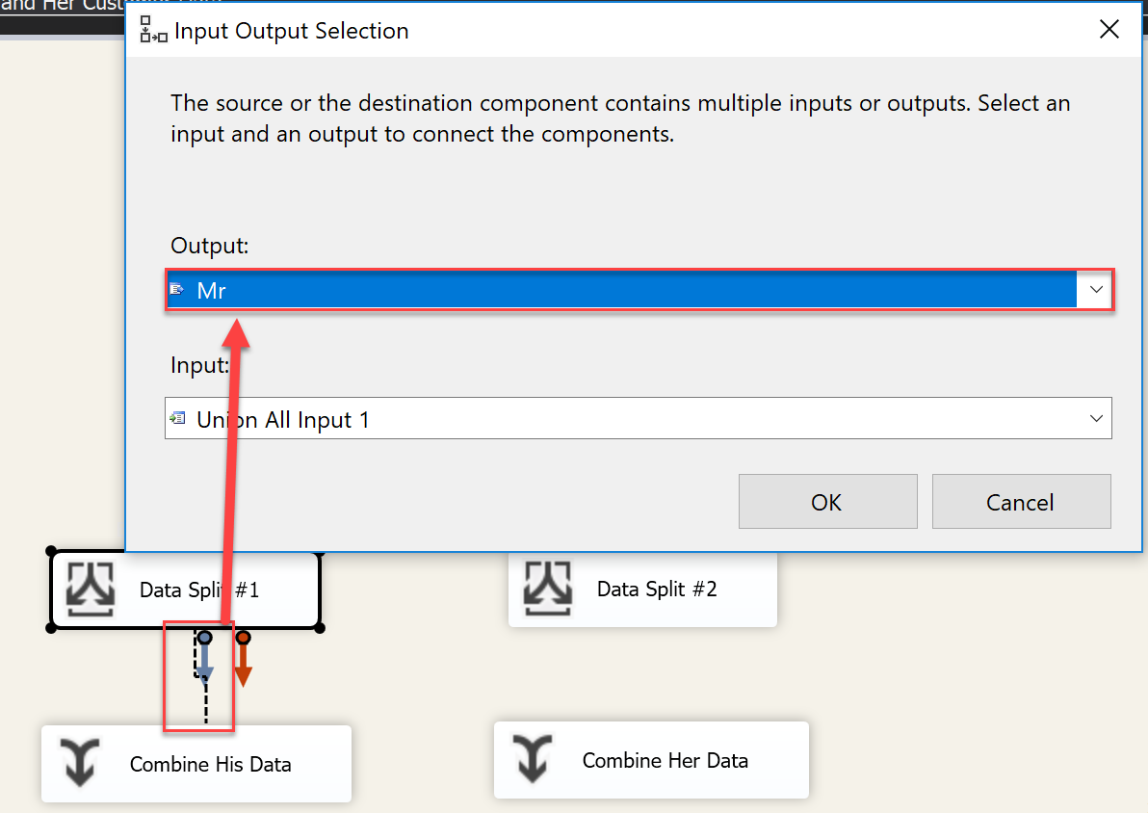
9. Drag an arrow from Data Split #2 and connecting to Combine Hist Data, again making sure to select “Mr” stream in output.  
   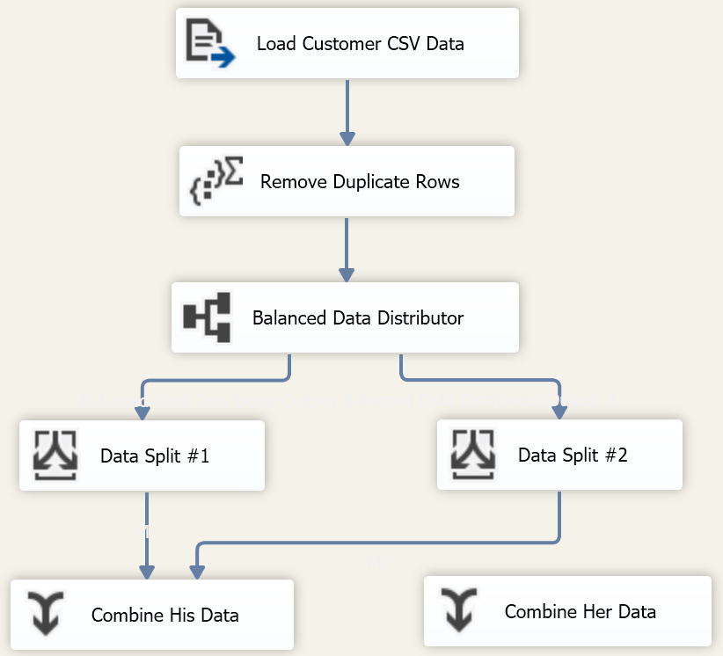
10. Do the same connection from Data Split #1 to Combine Her Data. This time notice dialog box only has “Her” stream left as an option.  
    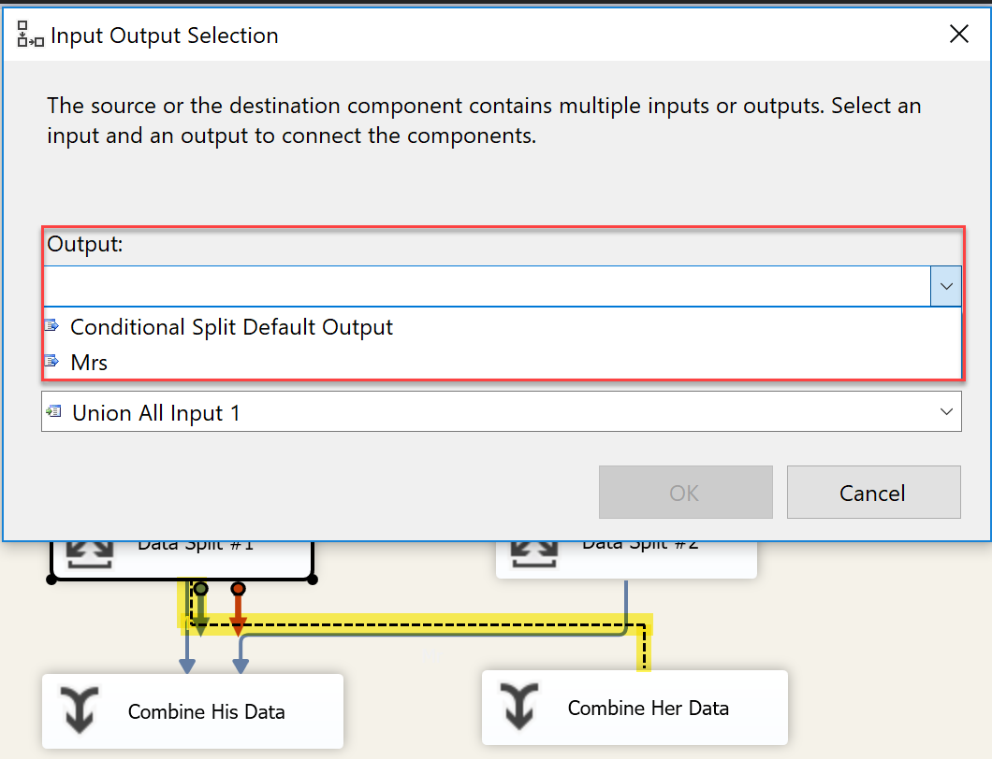
11. Next link the “Data Split #2” to “Combine Her Data”, making sure to like “Mrs” stream in output.  
    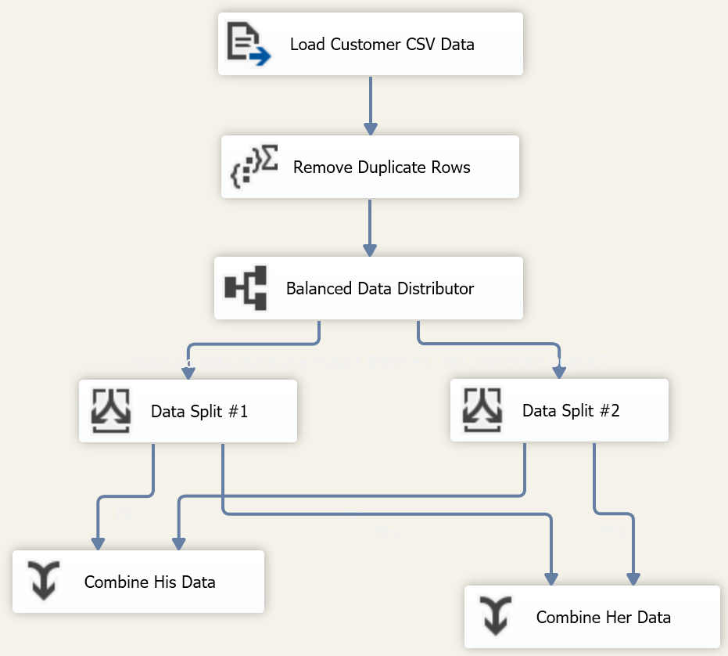
12. Add two “Derived Column” tasks. Rename one task to “His Full Name” another to “Her Full Name”. Link the respective tasks to their “Combine His Data” or “Combine Her Data”.  
    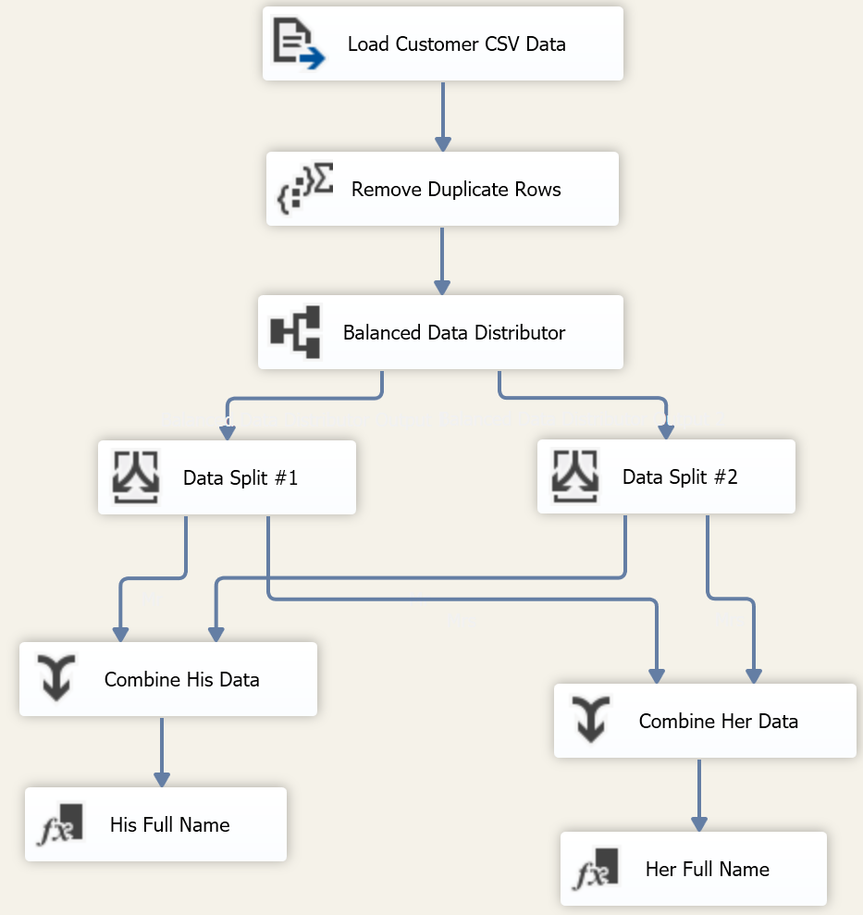
13. Double-click on “His Full Name”, build a new derived column with expression in screenshot below.  
    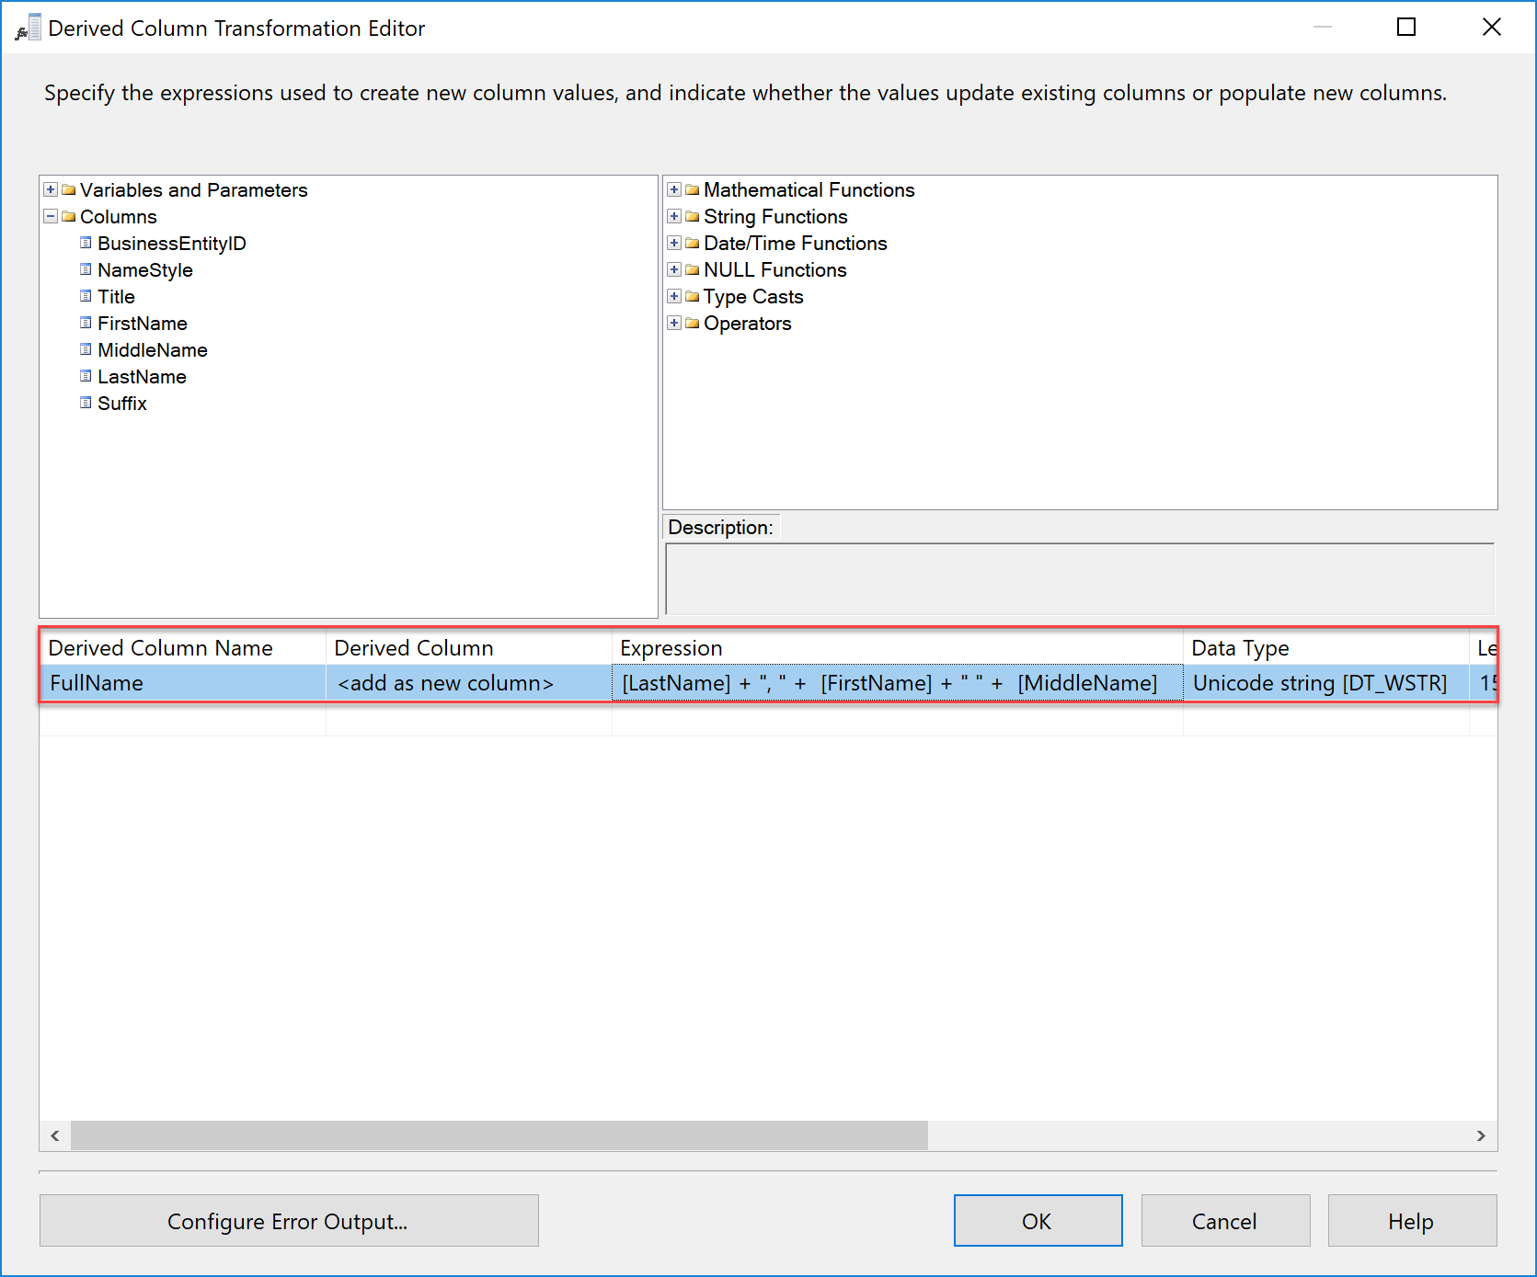
14. Create the same expression in “Her Full Name”.
15. Create two Sort Tasks, rename one to “Sort His Data” another to “Sort Her Data”. Link them to their respective derived column task.  
    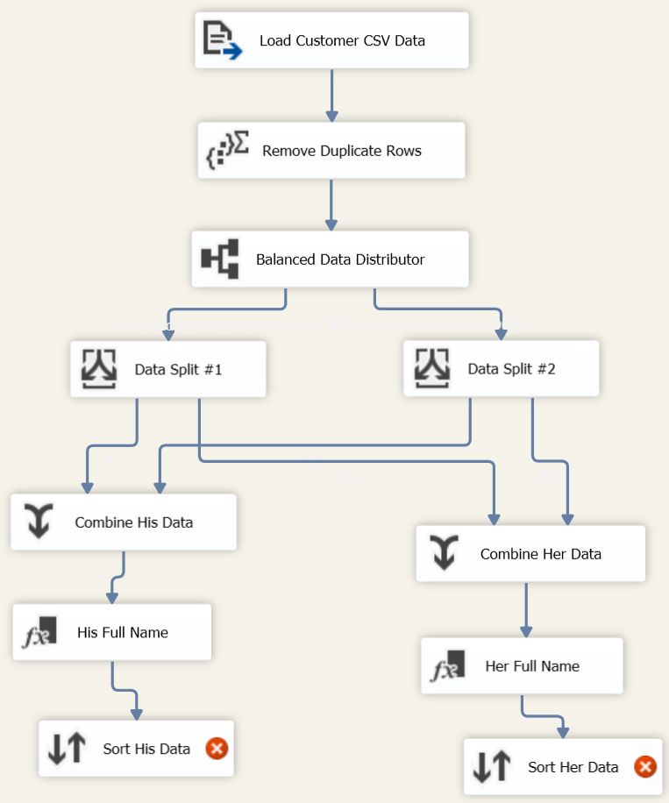
16. Configure the sort and define the sort of key as below for each task.  
    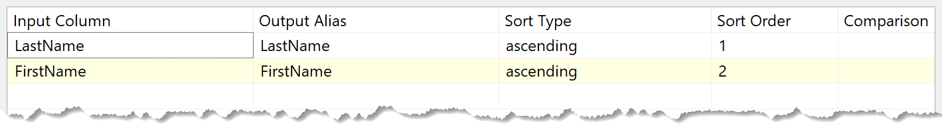
17. Create two new tasks for OLE DB Destination, rename one to “Save MrData” and other to “Save MrData”. Link them to their respective Sort tasks.

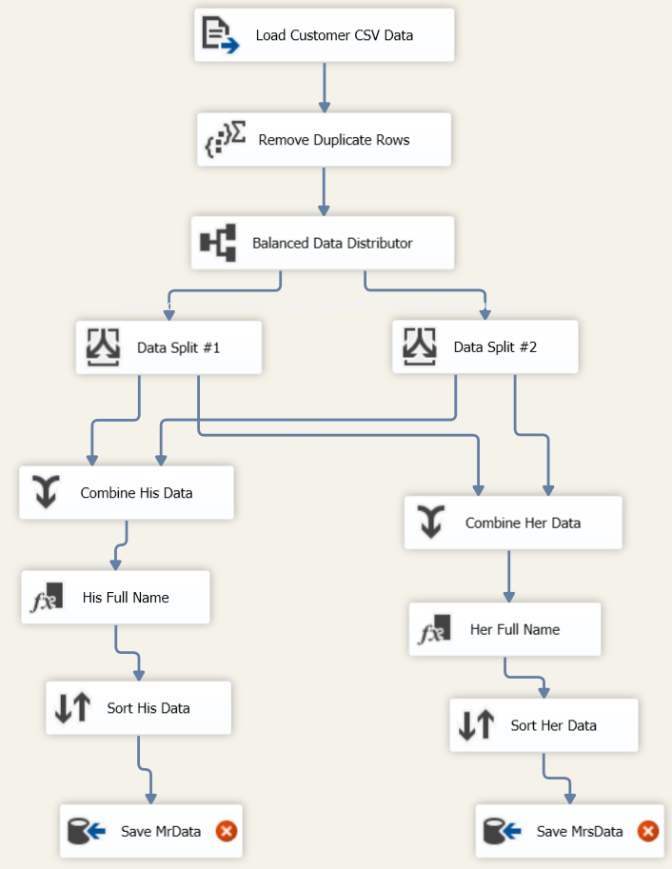

1. Double-click on “Save MrData”. Connect it to connection string build in step #7 and change the table to “dbo.MrData”. After connecting click on Column mapping to finalize mapping and click OK.  
   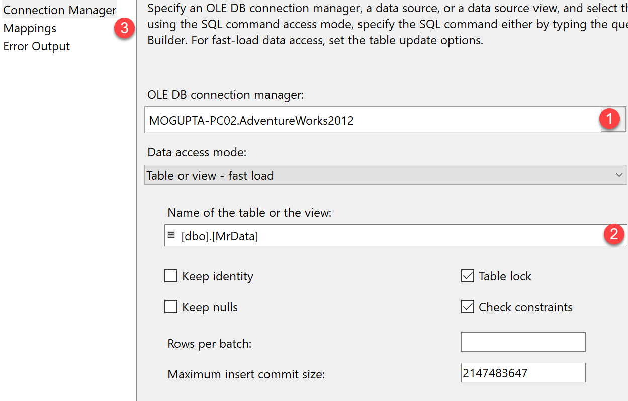
2. Follow the same steps for “Save MrsData”. Connecting to “dbo.MrsData” table.  
   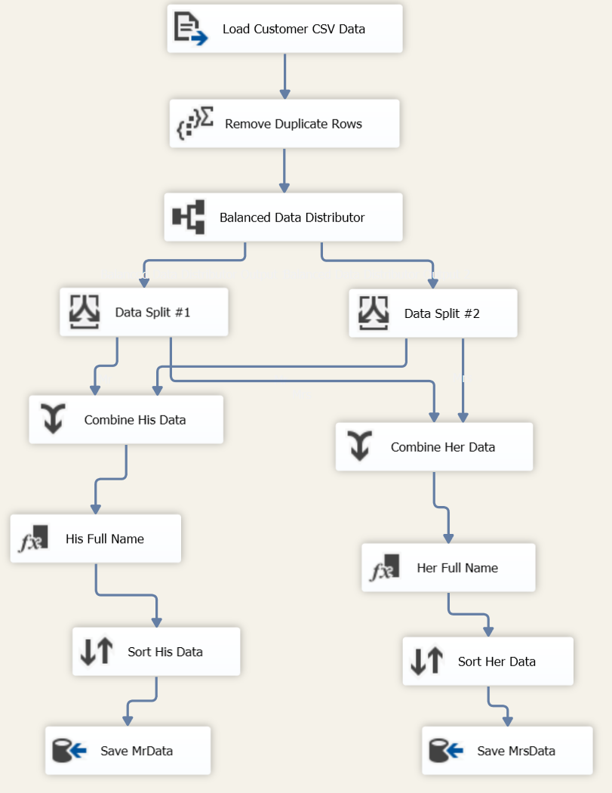
3. Execute task. Go to SQL Server and verify data in each table by executing “SELECT * FROM dbo.MrData” and “SELECT * FROM dbo.MrsData”.
4. As an extra challenge try the same exercise with using CustomerData_10MRows.csv file instead of the CustomerData.csv. Try adjusting properties for each task to see if you can make it run faster.